**Jaypee Institute of Information Technology, Noida**

ALGORITHM AND PROBLEM SOLVING LAB

(15B17CI471)

**Report**

**Group Members**

|  |  |  |
| --- | --- | --- |
| Batch | Name | Enroll |
| B4 | Naman Kumar | 20103092 |
| B4 | Siddhartha Kaushik | 20102118 |
| B4 | Pratyasha Shukla | 20103118 |
| B4 | Tarush Mittal | 20103021 |

**Title:**

**Code Salad**

Submitted to:

**Suma Dawn**(ASSISTANT PROFESSOR (SENIOR GRADE))

**Algorithms Used**

* Recursion
* Dynamic Programing
* Brute Force
* Vitter Algorithm
* Shanon Fano Algorithm
* Greedy Algorithm

**Introduction**

Code Salad is a program which let user ENCODE or DECODE data where encoding can be compressed also.In encoding user is given an option either to encode/decode the given string or to enter a string.

The User Can also analyse the Time Complexity, Time Taken,Difficulty Level of the given technique

Encoding Types:

* Huffman compression
* Huffman compression works by taking existing 8 bit characters and assigning them to a smaller number of bits. To optimize the compression, the characters with the highest frequency are given smaller bit values. A Huffman Tree helps us assign and visualize the new bit value assigned to existing characters.

There are mainly two major parts in Huffman Coding

1. Build a Huffman Tree from input characters.
2. Traverse the Huffman Tree and assign codes to characters.

* Shanon Fano compression
* Shannon Fano Algorithm is an entropy encoding technique for lossless data compression of multimedia. Named after Claude Shannon and Robert Fano, it assigns a code to each symbol based on their probabilities of occurrence. It is a variable-length encoding scheme, that is, the codes assigned to the symbols will be of varying length.

The steps of the algorithm are as follows:

1. Create a list of probabilities or frequency counts for the given set of symbols so that the relative frequency of occurrence of each symbol is known.

2. Sort the list of symbols in decreasing order of probability, the most probable ones to the left and least probable to the right.

3. Split the list into two parts, with the total probability of both the parts being as close to each other as possible.

4. Assign the value 0 to the left part and 1 to the right part.

5. Repeat steps 3 and 4 for each part, until all the symbols are split into individual subgroups.

* LZ77 compression
* LZ77 algorithms achieve compression by replacing repeated occurrences of data with references to a single copy of that data existing earlier in the uncompressed data stream. A match is encoded by a pair of numbers called a *length-distance pair*, which is equivalent to the statement "each of the next *length* characters is equal to the characters exactly *distance* characters behind it in the uncompressed stream".

Pseudo Code

**while** input is not empty **do**

match := longest repeated occurrence of input that begins in window

**if** match exists **then**

d := distance to start of match

l := length of match

c := char following match in input

**else**

d := 0

l := 0

c := first char of input

**end if**

**output** (d, l, c)

discard *l* + 1 chars from front of window

s := pop *l* + 1 chars from front of input

append s to back of window

**repeat**

* Adaptive Huffman compression
* Adaptive Huffman Coding is also known as Dynamic Huffman Coding. The implementation is done using Vitter Algorithm.

Decoding:

1. Read Binary string
2. If encountered leaf node is NYT
   * Read next e bits
     1. If e bit value < r, Then to get required symbol convert (e+1) bits to decimal value of (e+1) bits + 1
     2. If e bit value > r, Then to get required symbol convert e bits to decimal value of e bits + r + 1

Encoding:

1. Initialize the tree with the NYT Node
2. For a symbol is recognized for the first time, the initial NYT node is further divided into an NYT Node and new Node initialize to that symbol and weight = 1.
3. Assign the sum of the weight of child nodes to the parent node
4. If a repeated symbol is encountered than weights are updated to that symbol.

* RLE encoding
* Run-length encoding ( RLE) is a form of lossless data compression in which runs of data (sequences in which the same data value occurs in many consecutive data elements) are stored as a single data value and count, rather than as the original run.

Pseudo Code

string encoding = "";

    int count;

    for (int i = 0; str[i]; i++)

    {

        // count occurrences of character at index `i`

        count = 1;

        while (str[i] == str[i + 1]) {

            count++, i++;

        }

        // append current character and its count to the result

        encoding += to_string(count) + str[i];

    }

* Pig Latin encoding

The first vowel occurring in the input word is placed at the start of the new word along with the remaining alphabet of it. The alphabet is present before the first vowel is shifted, at the end of the new word it is followed by “ay”.

Find index of first vowel.

2) Create pig latin by appending following three.

.....a) Substring after starting with the first vowel till end.

.....b) Substring before first vowel.

.....c) "ay".

Example:

Input: s = "amazon"

Output: amazonay

Decoding Types:

* Huffman Decoding
* Huffman coding first creates a tree using the frequencies of the character and then generates code for each character. Once the data is encoded, it has to be decoded.

To find character corresponding to current bits, we use following simple steps.

1. We start from root and do following until a leaf is found.
2. If current bit is 0, we move to left node of the tree.
3. If the bit is 1, we move to right node of the tree.
4. If during traversal, we encounter a leaf node, we print character of that particular leaf node and then again continue the iteration of the encoded data starting from step 1.

* LZ77 Decoding
* RLE Decoding

Run-length encoding (RLE) is a lossless compression method where sequences that display redundant data are stored as a single data value representing the repeated block and how many times it appears in the image. Later, during decompression, the image can be reconstructed exactly from this information

Approach:

* Traverse through the linked list.
* Store the current character in a variable **c**.
* Check if the next node is a number and store the number in **count** else **count** is **1**.
* Append the character **c** to the list **count** times
* Latin Alphabet Decoding

The Latin Alphabet Cipher Encryption Technique is one of the earliest and simplest techniques of encrypting data. It’s simply a type of substitution cipher technique, i.e., each letter of a given text is substituted by its corresponding number as represented in its alphabetical order

Algorithm:

1. For every alphabet calculate the cost of decryption
2. Then run loop for finding the end or null point

* Median Decoding

In this we add the previous binary code in the string to the next set of binary code and thus the output is obtained by adding the two till we reach at a point where the binary code terminates.

Approach :

It can be observed that while decoding the string, the first letter of the encoded string becomes the median of the decoded string. So first, write the very first character of the encoded string and remove it from the encoded string then start adding the first character of the encoded string first to the left and then to the right of the decoded string and do this task repeatedly till the encoded string becomes empty.

ENCODE

DECODE

COMPRESSED

NORMAL

HUFFMAN

SHANON FANO

ADAPTIVE HUFFMAN

LZ77

LATIN ALPHABET

RLE

MEDIAN

PIG LATIN

**SNAPSHOTS**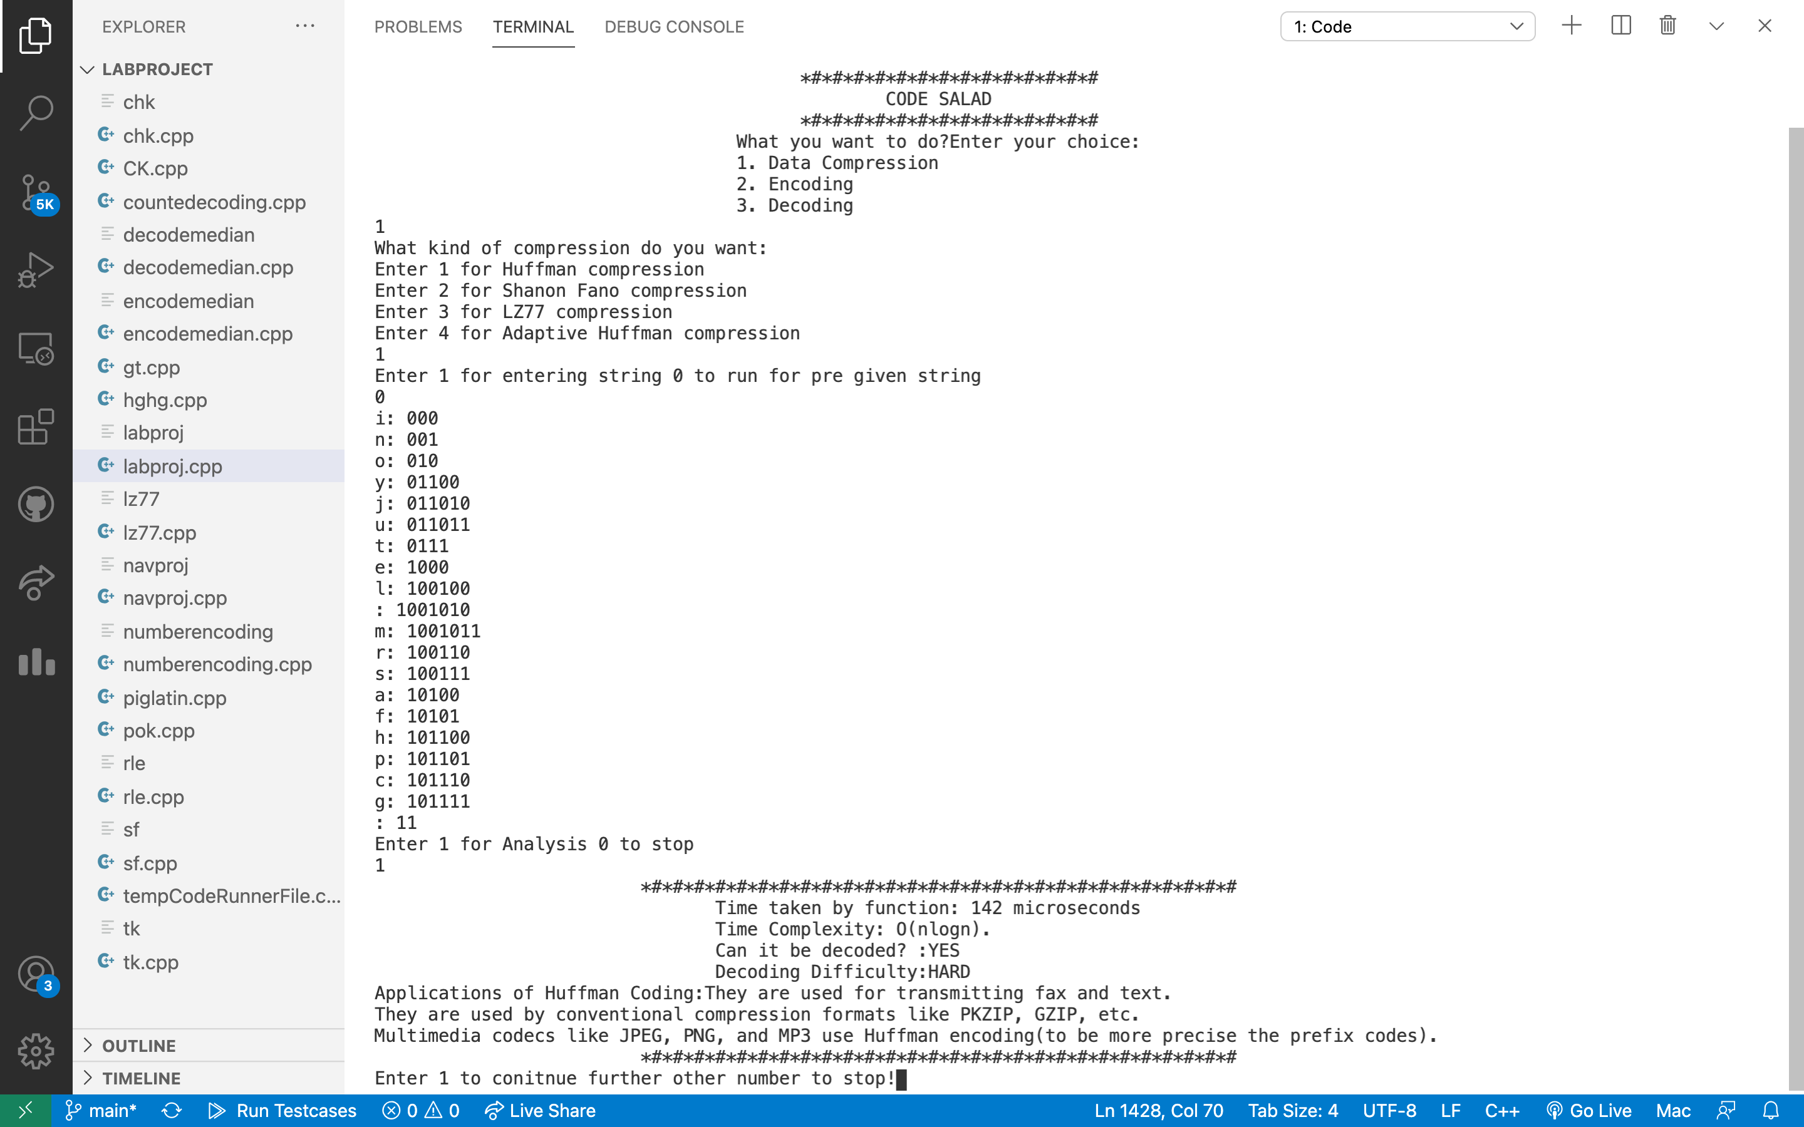

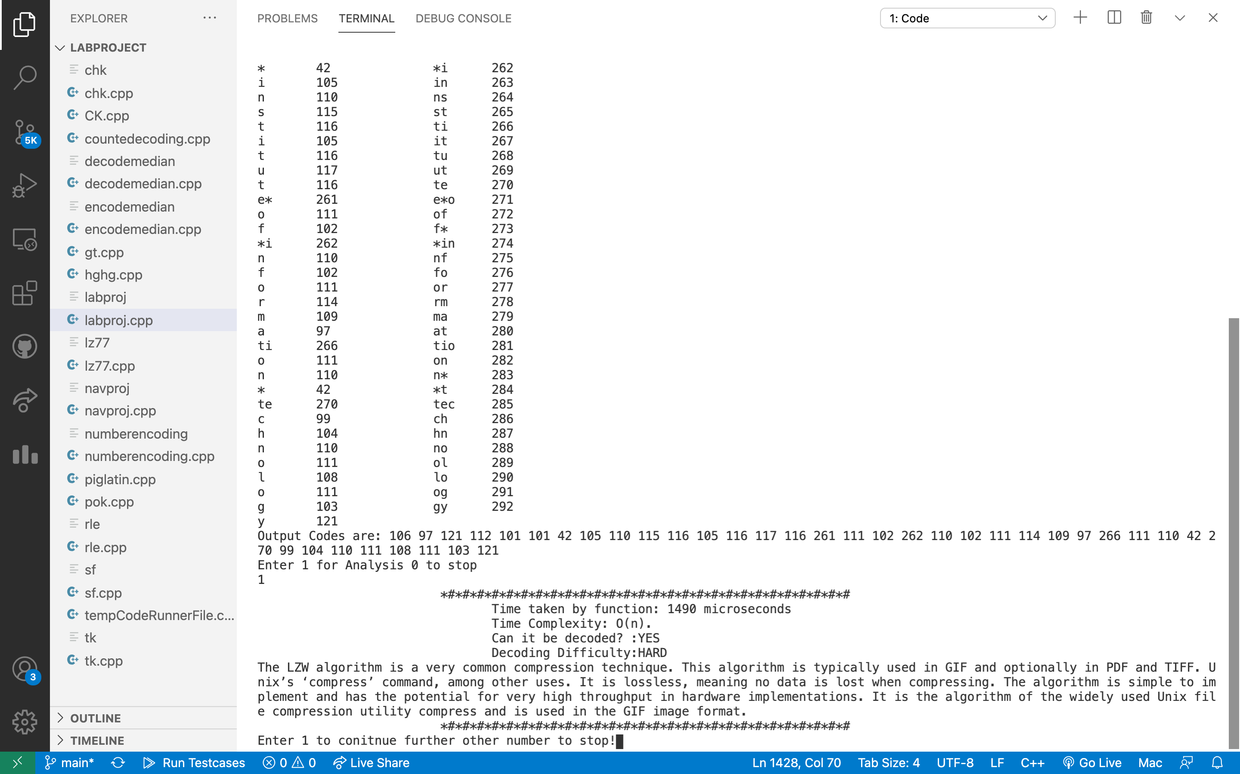

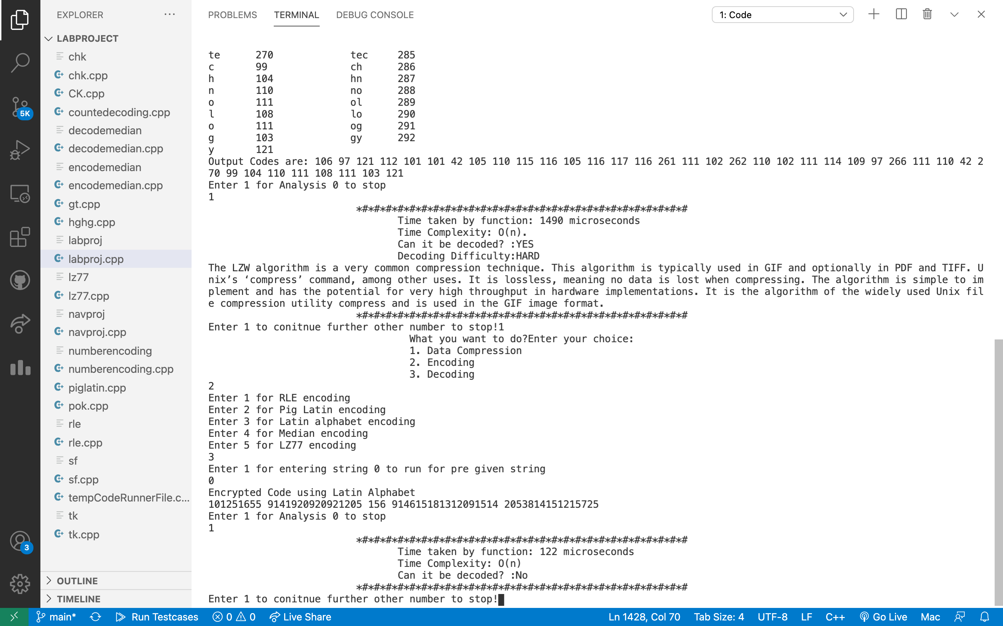

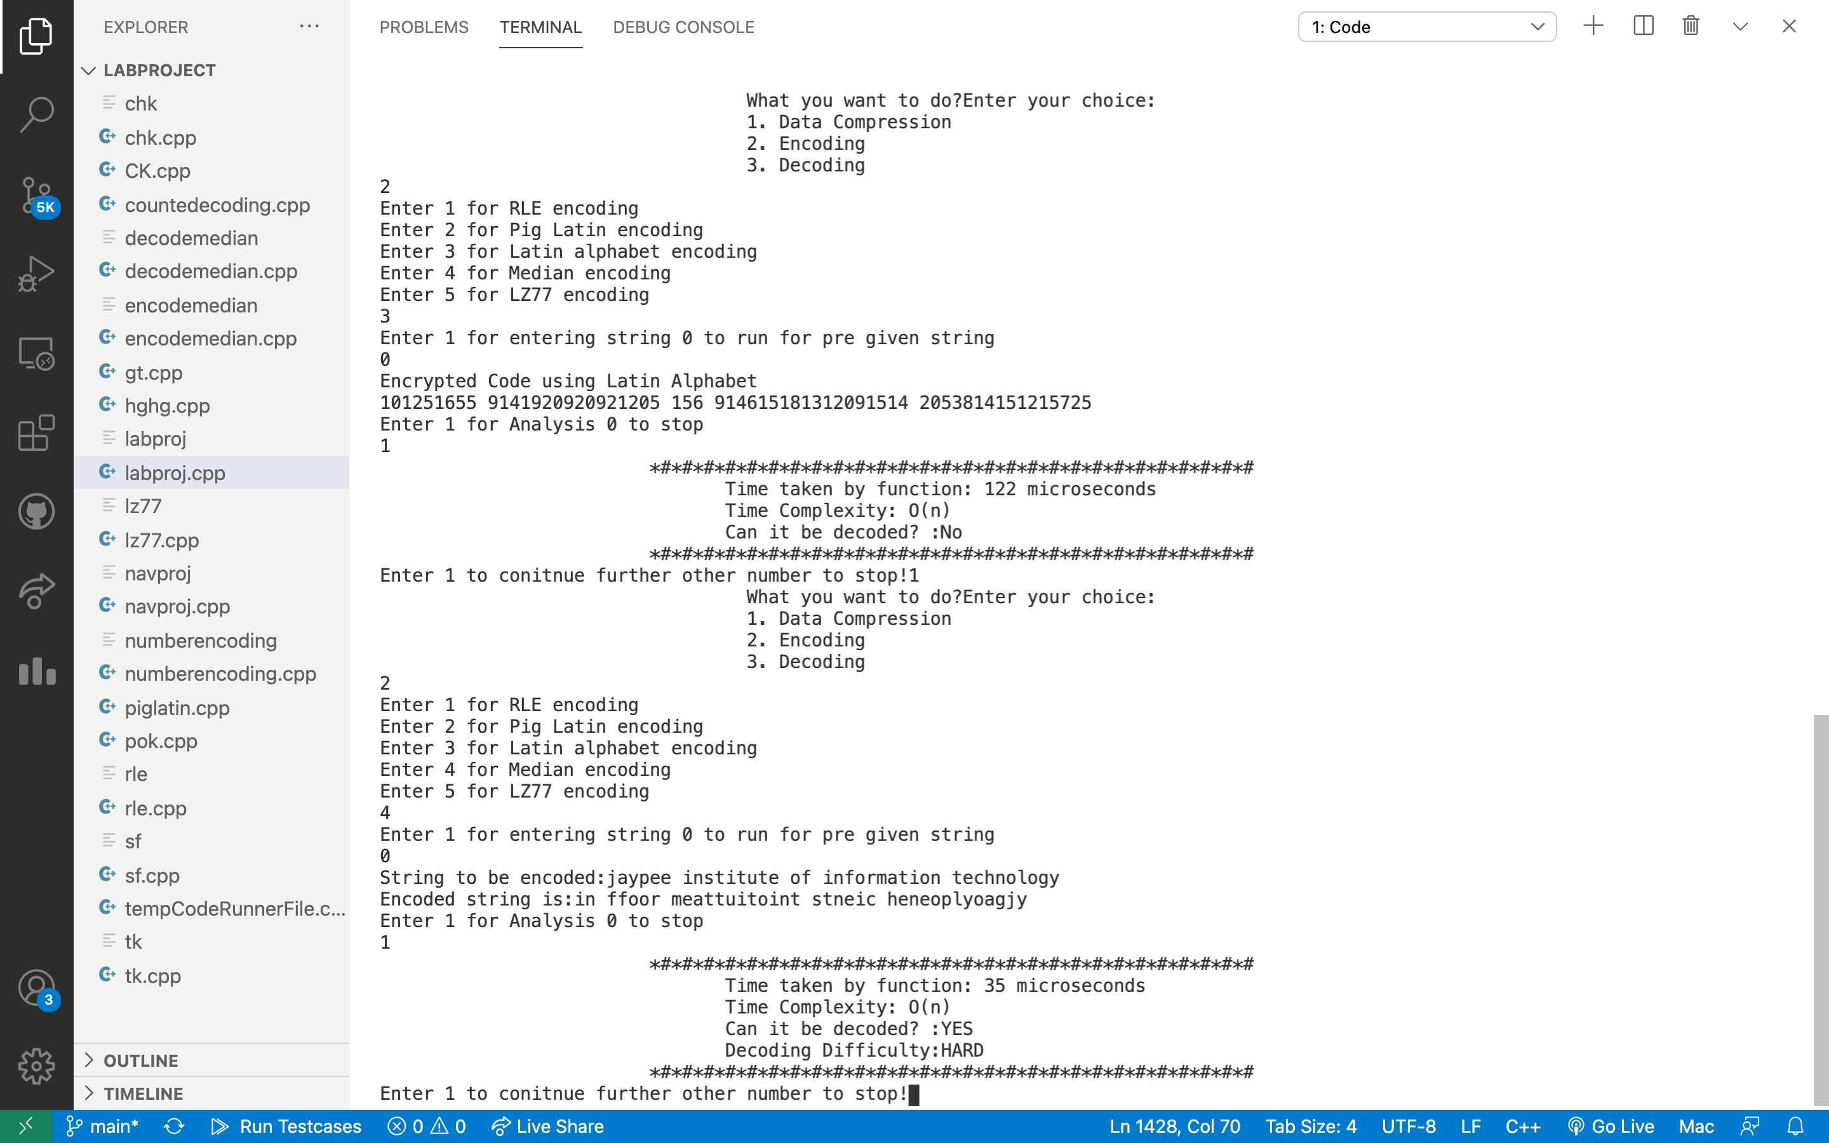

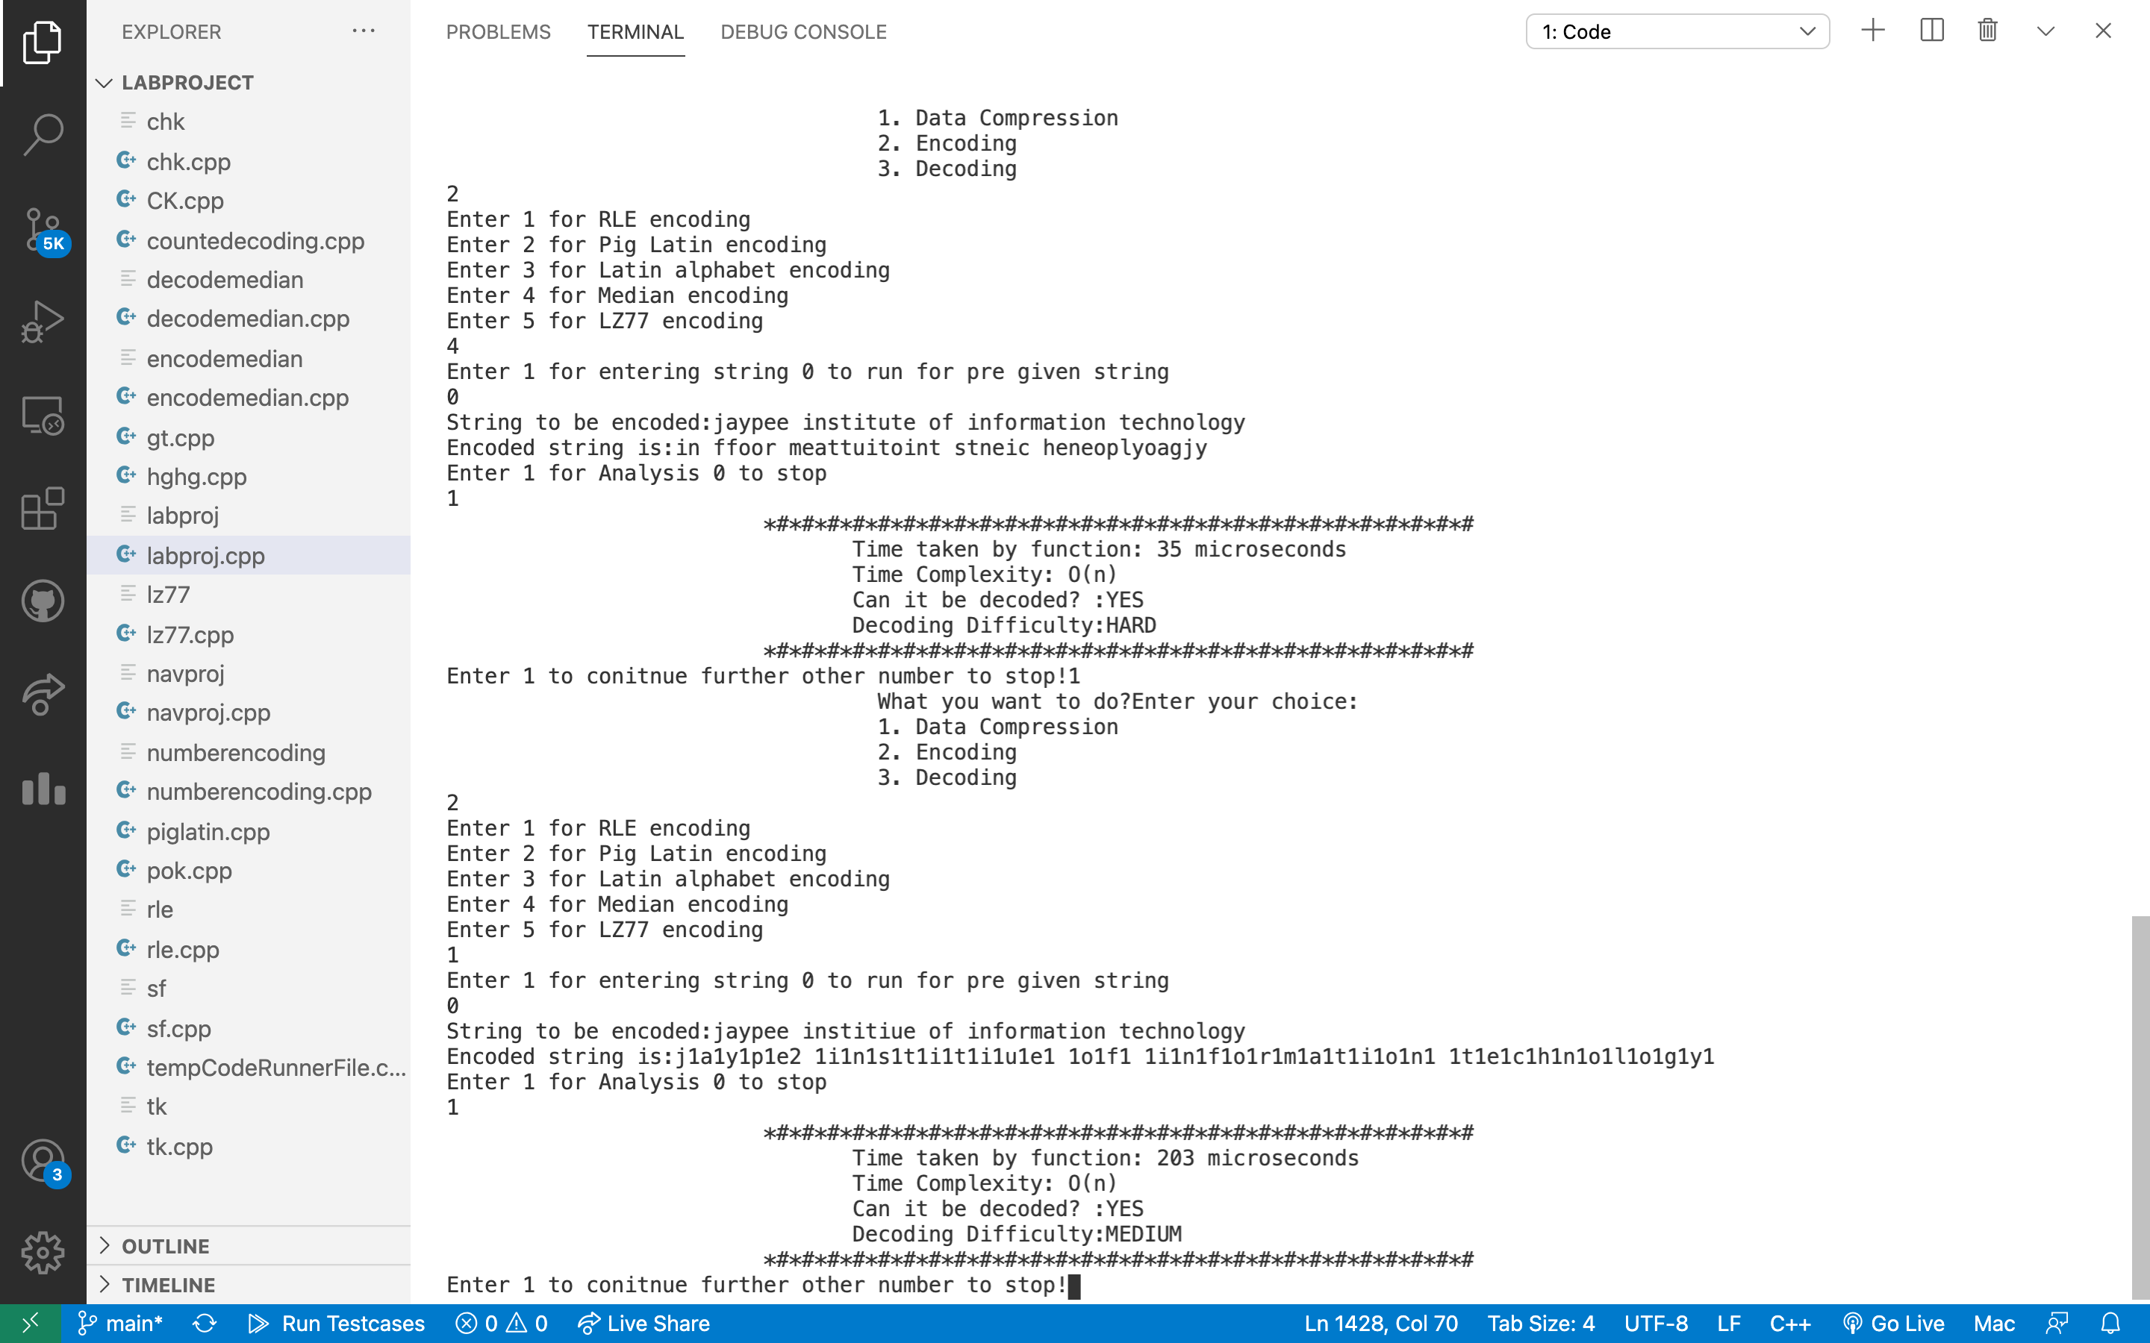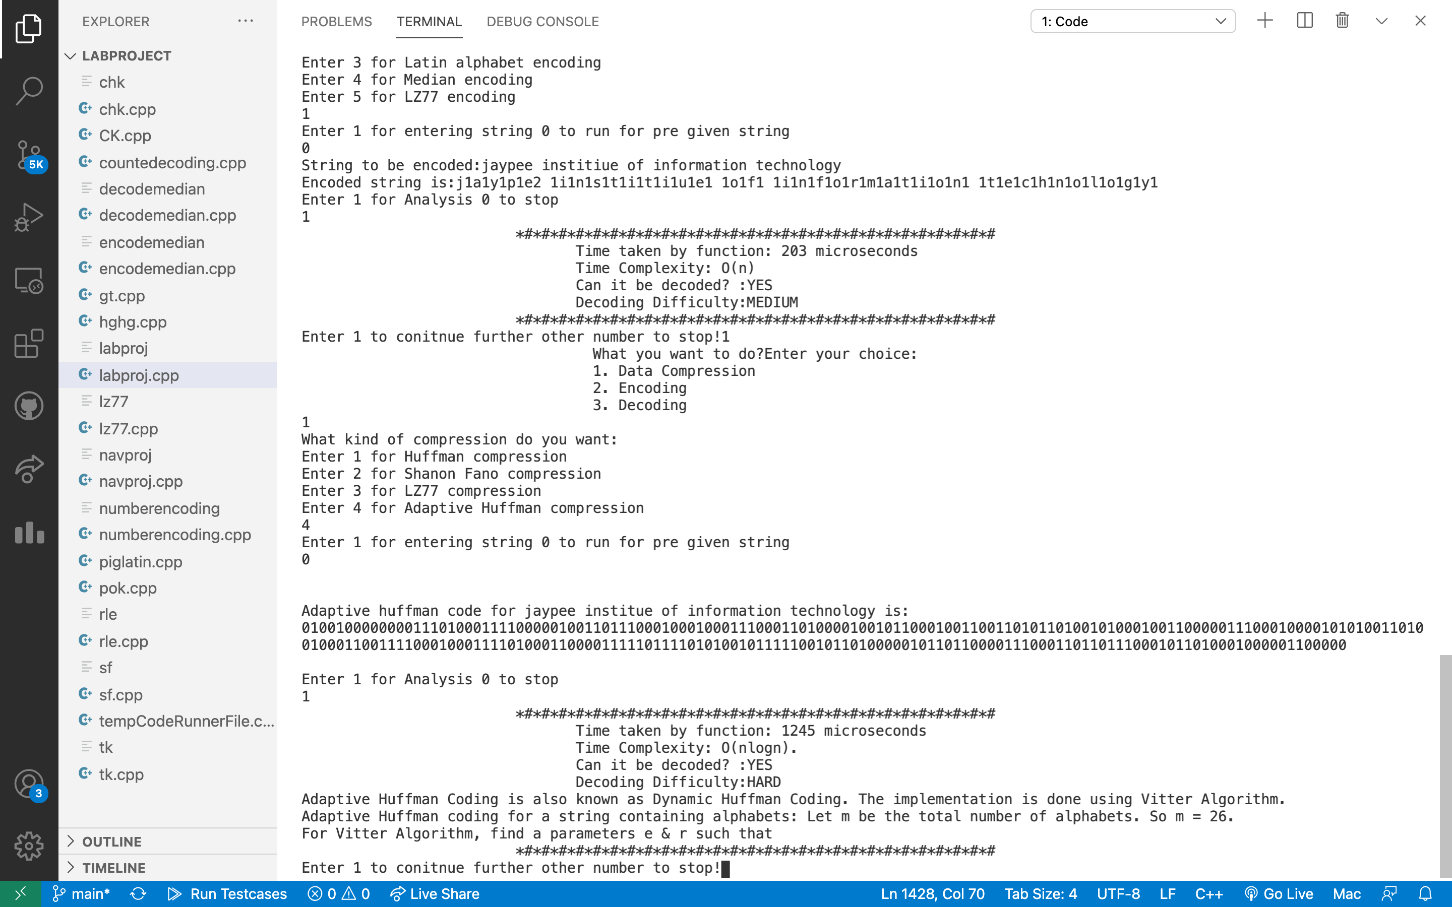

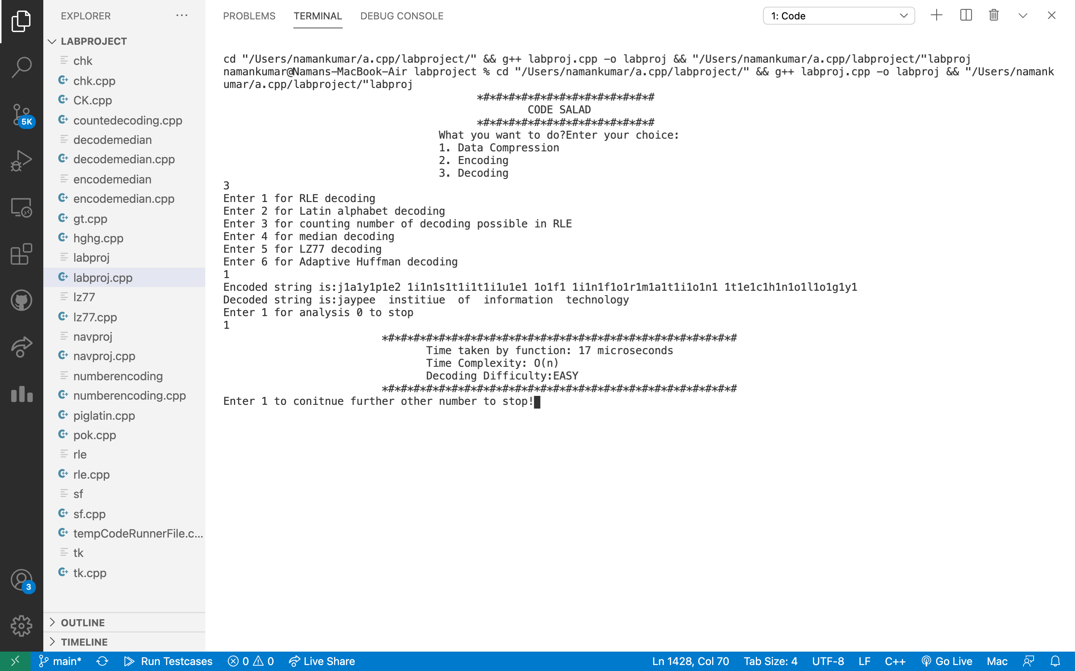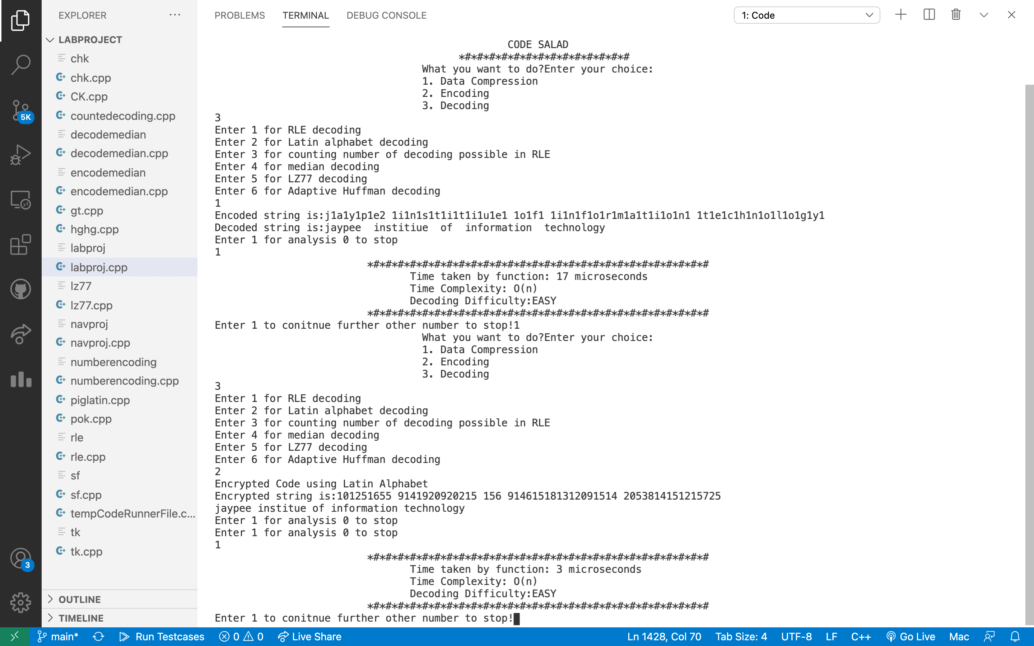

**CODE**

#include <bits/stdc++.h>

#include<stdlib.h>

using namespace std;

using namespace std::chrono;

#define MAX_TREE_HT 100

#define MAX_RLEN 50

class node1{

public:

string ch;

int weight;

int no;

int left;

int right;

int parent;

string code;

};

long int tot=0;

string data1="jaypee institue of information technology";

string output="";

vector<node1>tree;

int NYT=0;

int node1No=51;

int currnode1;

void createnode1(string,int,int,int,string);

void encode1();

bool first1(int);

string retCodedata1(string);

string givencode1(char);

void update1(bool,string);

void gotoParent1(int);

int findnode1Max1(int);

void switchnode1s1(int,int);

void reNumCode1(int);

void display1();

void decode1();

int b_to_d(string);

string givenCode2(int,int);

bool first2(string);

struct MinHeapNode {

char data;

unsigned freq;

struct MinHeapNode *left, *right;

};

struct MinHeap {

unsigned size;

unsigned capacity;

struct MinHeapNode** array;

};

struct MinHeapNode* newNode(char data, unsigned freq)

{

struct MinHeapNode* temp = (struct MinHeapNode*)malloc(

sizeof(struct MinHeapNode));

temp->left = temp->right = NULL;

temp->data = data;

temp->freq = freq;

return temp;

}

struct MinHeap* createMinHeap(unsigned capacity)

{

struct MinHeap* minHeap

= (struct MinHeap*)malloc(sizeof(struct MinHeap));

minHeap->size = 0;

minHeap->capacity = capacity;

minHeap->array = (struct MinHeapNode**)malloc(

minHeap->capacity * sizeof(struct MinHeapNode*));

return minHeap;

}

void swapMinHeapNode(struct MinHeapNode** a,

struct MinHeapNode** b)

{

struct MinHeapNode* t = *a;

*a = *b;

*b = t;

}

void minHeapify(struct MinHeap* minHeap, int idx)

{

int smallest = idx;

int left = 2 * idx + 1;

int right = 2 * idx + 2;

if (left < minHeap->size

&& minHeap->array[left]->freq

< minHeap->array[smallest]->freq)

smallest = left;

if (right < minHeap->size

&& minHeap->array[right]->freq

< minHeap->array[smallest]->freq)

smallest = right;

if (smallest != idx) {

swapMinHeapNode(&minHeap->array[smallest],

&minHeap->array[idx]);

minHeapify(minHeap, smallest);

}

}

int isSizeOne(struct MinHeap* minHeap)

{

return (minHeap->size == 1);

}

struct MinHeapNode* extractMin(struct MinHeap* minHeap)

{

struct MinHeapNode* temp = minHeap->array[0];

minHeap->array[0] = minHeap->array[minHeap->size - 1];

--minHeap->size;

minHeapify(minHeap, 0);

return temp;

}

void insertMinHeap(struct MinHeap* minHeap,

struct MinHeapNode* minHeapNode)

{

++minHeap->size;

int i = minHeap->size - 1;

while (i

&& minHeapNode->freq

< minHeap->array[(i - 1) / 2]->freq) {

minHeap->array[i] = minHeap->array[(i - 1) / 2];

i = (i - 1) / 2;

}

minHeap->array[i] = minHeapNode;

}

void buildMinHeap(struct MinHeap* minHeap)

{

int n = minHeap->size - 1;

int i;

for (i = (n - 1) / 2; i >= 0; --i)

minHeapify(minHeap, i);

}

void printArr(int arr[], int n)

{

int i;

for (i = 0; i < n; ++i)

printf("%d", arr[i]);

printf("\n");

}

int isLeaf(struct MinHeapNode* root)

{

return !(root->left) && !(root->right);

}

struct MinHeap* createAndBuildMinHeap(char data[],

int freq[], int size)

{

struct MinHeap* minHeap = createMinHeap(size);

for (int i = 0; i < size; ++i)

minHeap->array[i] = newNode(data[i], freq[i]);

minHeap->size = size;

buildMinHeap(minHeap);

return minHeap;

}

struct MinHeapNode* buildHuffmanTree(char data[],

int freq[], int size)

{

struct MinHeapNode *left, *right, *top;

struct MinHeap* minHeap

= createAndBuildMinHeap(data, freq, size);

while (!isSizeOne(minHeap)) {

left = extractMin(minHeap);

right = extractMin(minHeap);

top = newNode('$', left->freq + right->freq);

top->left = left;

top->right = right;

insertMinHeap(minHeap, top);

}

return extractMin(minHeap);

}

void printCodes(struct MinHeapNode* root, int arr[],

int top)

{

if (root->left) {

arr[top] = 0;

printCodes(root->left, arr, top + 1);

}

if (root->right) {

arr[top] = 1;

printCodes(root->right, arr, top + 1);

}

if (isLeaf(root)) {

string str=to_string(root->data);

tot+=str.length();

printf("%c: ", root->data);

printArr(arr, top);

}

}

void HuffmanCodes(char data[], int freq[], int size)

{

struct MinHeapNode* root

= buildHuffmanTree(data, freq, size);

int arr[MAX_TREE_HT], top = 0;

printCodes(root, arr, top);

}

struct node {

string sym;

float pro;

int arr[20];

int top;

} p[20];

typedef struct node node;

void shannon(int l, int h, node p[])

{

float pack1 = 0, pack2 = 0, diff1 = 0, diff2 = 0;

int i, d, k, j;

if ((l + 1) == h || l == h || l > h) {

if (l == h || l > h)

return;

p[h].arr[++(p[h].top)] = 0;

p[l].arr[++(p[l].top)] = 1;

return;

}

else {

for (i = l; i <= h - 1; i++)

pack1 = pack1 + p[i].pro;

pack2 = pack2 + p[h].pro;

diff1 = pack1 - pack2;

if (diff1 < 0)

diff1 = diff1 * -1;

j = 2;

while (j != h - l + 1) {

k = h - j;

pack1 = pack2 = 0;

for (i = l; i <= k; i++)

pack1 = pack1 + p[i].pro;

for (i = h; i > k; i--)

pack2 = pack2 + p[i].pro;

diff2 = pack1 - pack2;

if (diff2 < 0)

diff2 = diff2 * -1;

if (diff2 >= diff1)

break;

diff1 = diff2;

j++;

}

k++;

for (i = l; i <= k; i++)

p[i].arr[++(p[i].top)] = 1;

for (i = k + 1; i <= h; i++)

p[i].arr[++(p[i].top)] = 0;

shannon(l, k, p);

shannon(k + 1, h, p);

}

}

void sortByProbability(int n, node p[])

{

int i, j;

node temp;

for (j = 1; j <= n - 1; j++) {

for (i = 0; i < n - 1; i++) {

if ((p[i].pro) > (p[i + 1].pro)) {

temp.pro = p[i].pro;

temp.sym = p[i].sym;

p[i].pro = p[i + 1].pro;

p[i].sym = p[i + 1].sym;

p[i + 1].pro = temp.pro;

p[i + 1].sym = temp.sym;

}

}

}

}

void display(int n, node p[])

{

int i, j;

cout << "\n\n\n\tSymbol\tProbability\tCode";

for (i = n - 1; i >= 0; i--) {

cout << "\n\t" << p[i].sym << "\t\t" << p[i].pro << "\t";

for (j = 0; j <= p[i].top; j++){

string str;

str=to_string(p[i].arr[j]);

tot+=str.length();

cout << p[i].arr[j];

}

}

}

vector<int> encoding(string s1)

{

cout << "Encoding\n";

unordered_map<string, int> table;

for (int i = 0; i <= 255; i++) {

string ch = "";

ch += char(i);

table[ch] = i;

}

string p = "", c = "";

p += s1[0];

int code = 256;

vector<int> output_code;

cout << "String\tOutput_Code\tAddition\n";

for (int i = 0; i < s1.length(); i++) {

if (i != s1.length() - 1)

c += s1[i + 1];

if (table.find(p + c) != table.end()) {

p = p + c;

}

else {

cout << p << "\t" << table[p] << "\t\t"

<< p + c << "\t" << code << endl;

output_code.push_back(table[p]);

table[p + c] = code;

code++;

p = c;

}

c = "";

}

cout << p << "\t" << table[p] << endl;

output_code.push_back(table[p]);

return output_code;

}

void decoding(vector<int> op)

{

cout << "\nDecoding\n";

unordered_map<int, string> table;

for (int i = 0; i <= 255; i++) {

string ch = "";

ch += char(i);

table[i] = ch;

}

int old = op[0], n;

string s = table[old];

string c = "";

c += s[0];

cout << s;

int count = 256;

for (int i = 0; i < op.size() - 1; i++) {

n = op[i + 1];

if (table.find(n) == table.end()) {

s = table[old];

s = s + c;

}

else {

s = table[n];

}

cout << s;

c = "";

c += s[0];

table[count] = table[old] + c;

count++;

old = n;

}

}

char* encode(char* src)

{

int rLen;

char count[MAX_RLEN];

int len = strlen(src);

char* dest = (char*)malloc(sizeof(char) * (len * 2 + 1));

int i, j = 0, k;

for (i = 0; i < len; i++) {

dest[j++] = src[i];

rLen = 1;

while (i + 1 < len && src[i] == src[i + 1]) {

rLen++;

i++;

}

sprintf(count, "%d", rLen);

for (k = 0; *(count + k); k++, j++) {

dest[j] = count[k];

}

}

dest[j] = '\0';

return dest;

}

bool isVowel(char c)

{

vector<char> v={'A','E','I','O','U','a','e','i','o','u'};

for(int i=0;i<10;i++){

if(v[i]==c)

return 1;

}

return 0;

}

string pigLatin(string s)

{

int len = s.length();

int index = -1;

for (int i = 0; i < len; i++) {

if (isVowel(s[i])) {

index = i;

break;

}

}

if (index == -1)

return "-1";

return s.substr(index) + s.substr(0, index) + "ay";

}

void cipher(string str)

{ int str1[str.length()];

for (int i = 0; i<str.length(); i++) {

if (isalpha(str[i]) == 0 && str[i] != ' ') {

cout<<str[i]<<endl;

cout<<"Enter only alphabets and space"<<endl;

return;

}

}

cout<<"Encrypted Code using Latin Alphabet"<<endl;

for (int i = 0; str[i] != '\0'; i++) {

if (str[i] >= 'A' && str[i] <= 'Z')

str1[i]=str[i] - 'A' + 1;

else if (str[i] >= 'a' && str[i] <= 'z')

str1[i]=str[i] - 'a' + 1;

if (str[i] == ' ')

str1[i]=str[i];

}

for(int i=0;i<str.length();i++){

if(str1[i]==32)

cout<<" ";

else

cout<<str1[i];

}

cout<<endl;

}

void decipher(string str){

int str1[str.length()];

for (int i = 0; i<str.length(); i++) {

if (isalpha(str[i]) == 0 && str[i] != ' ') {

cout<<str[i]<<endl;

cout<<"Enter only alphabets and space"<<endl;

return;

}

}

cout<<"Encrypted Code using Latin Alphabet"<<endl;

for (int i = 0; str[i] != '\0'; i++) {

if (str[i] >= 'A' && str[i] <= 'Z')

str1[i]=str[i] - 'A' + 1;

else if (str[i] >= 'a' && str[i] <= 'z')

str1[i]=str[i] - 'a' + 1;

if (str[i] == ' ')

str1[i]=str[i];

}

cout<<"Encrypted string is:";

for(int i=0;i<str.length();i++){

if(str1[i]==32)

cout<<" ";

else

cout<<str1[i];

}

cout<<endl;

for(int i=0;i<str.length();i++){

if(str1[i]==32)

cout<<" ";

else

cout<<(char)(str1[i]+'a'-1);

}

cout<<endl;

}

void decodeRLE(char* res){

for(int i=0;i<strlen(res);i++){

//cout<<res[i]<<endl;

if(res[i]==' ')

cout<<" ";

else if(res[i]<'a'||res[i]>'z'){

int count=res[i]-'0';

//cout<<count<<endl;

while(count!=0){

cout<<res[i-1];

count--;

}

}

}

cout<<endl;

}

int countDecodingDP(char *digits, int n)

{

int count[n+1];

count[0] = 1;

count[1] = 1;

if(digits[0]=='0')

return 0;

for (int i = 2; i <= n; i++)

{

count[i] = 0;

if (digits[i-1] > '0')

count[i] = count[i-1];

if (digits[i-2] == '1' ||

(digits[i-2] == '2' && digits[i-1] < '7') )

count[i] += count[i-2];

}

return count[n];

}

string encodeMedianString(string s)

{

int l = s.length();

string s1 = "";

bool isEven = (l % 2 == 0)? true : false;

int i,j;

if(!isEven){

s1+=s[l/2];

i=l/2+1;

j=l/2-1;

}

else{

i=l/2;

j=l/2-1;

}

for (; i < l; i++,j--) {

// cout<<i<<" hi"<<endl;

s1=s1+s[j];

s1=s1+s[i];

}

return s1;

}

string decodeMedianString(string s)

{

int l = s.length();

string s1 = "";

bool isEven = (l % 2 == 0)? true : false;

for (int i = 0; i < l; i += 2) {

if (isEven) {

s1 = s[i] + s1;

s1 += s[i + 1];

} else {

if (l - i > 1) {

s1 += s[i];

s1 = s[i + 1] + s1;

} else {

s1 += s[i];

}

}

}

return s1;

}

void createnode1(string str,int num,int freq,int p,string c){

node1 temp;

temp.ch=str;

temp.no=num;

temp.weight=freq;

temp.left=-1;

temp.right=-1;

temp.parent=p;

temp.code=c;

tree.push_back(temp);

}

void encode1(){

bool first1Flag;

for(int a=0;a<data1.length();a++){

first1Flag=false;

if(first1(a)){

first1Flag=true;

output+=tree[NYT].code;

output+=givencode1(data1[a]);

} else {

output+=retCodedata1(string(1,data1[a]));

}

update1(first1Flag,string(1,data1[a]));

}

}

//return true if symbol is first1 appearance

bool first1(int n){

for(int a=0;a<n;a++){

if(data1[a]==data1[n]){

return false;

}

}

return true;

}

//return code for the data1 element

string retCodedata1(string str){

for(int a=0;a<tree.size();a++){

if(str==tree[a].ch){

currnode1=a;

return tree[a].code;

}

}

return "";

}

//return code for specific data1 element

string givencode1(char str){

switch(str){

case 'a':return "00000";break;

case 'b':return "00001";break;

case 'c':return "00010";break;

case 'd':return "00011";break;

case 'e':return "00100";break;

case 'f':return "00101";break;

case 'g':return "00110";break;

case 'h':return "00111";break;

case 'i':return "01000";break;

case 'j':return "01001";break;

case 'k':return "01010";break;

case 'l':return "01011";break;

case 'm':return "01100";break;

case 'n':return "01101";break;

case 'o':return "01110";break;

case 'p':return "01111";break;

case 'q':return "10000";break;

case 'r':return "10001";break;

case 's':return "10010";break;

case 't':return "10011";break;

case 'u':return "1010";break;

case 'v':return "1011";break;

case 'w':return "1100";break;

case 'x':return "1101";break;

case 'y':return "1110";break;

case 'z':return "1111";break;

default:return "";

}

}

//update1 the tree

void update1(bool flag,string str){

if(flag){

tree[NYT].ch="-";

tree[NYT].left=tree.size();

tree[NYT].right=tree.size()+1;

createnode1("NYT",tree[NYT].no-2,0,NYT,tree[NYT].code+"0");

createnode1(str,tree[NYT].no-1,1,NYT,tree[NYT].code+"1");

tree[NYT].weight++;

NYT=tree[NYT].left;

currnode1=tree[NYT].parent;

} else {

int node1Max=findnode1Max1(currnode1);

if(node1Max>0){

switchnode1s1(currnode1,node1Max);

}

tree[currnode1].weight++;

}

gotoParent1(currnode1);

}

//goto parent of node1

void gotoParent1(int n){

int node1Max;

while(tree[n].parent!=-1){

n=tree[n].parent;

node1Max=findnode1Max1(n);

if(node1Max<0){

tree[n].weight++;

} else {

switchnode1s1(n,node1Max);

reNumCode1(0);

tree[n].weight++;

node1No=51;

}

}

}

//return the node1 index with max node1 no. in block else -1

int findnode1Max1(int n){

int w=tree[n].weight;

int index=n;

for(int a=0;a<tree.size();a++){

if(tree[a].weight==w&&tree[a].no>tree[index].no){

index=a;

}

}

if(index==n){

return -1;

}

return index;

}

//switch the node1s

void switchnode1s1(int a,int b){

//swap parent's child

int parent_a=tree[a].parent;

int parent_b=tree[b].parent;

int parent_a_left=tree[parent_a].left;

int parent_a_right=tree[parent_a].right;

int parent_b_left=tree[parent_b].left;

int parent_b_right=tree[parent_b].right;

//swap no.

int temp=tree[a].no;

tree[a].no=tree[b].no;

tree[b].no=temp;

//swap code

string str=tree[a].code;

tree[a].code=tree[b].code;

tree[b].code=str;

//swap parent

temp=tree[a].parent;

tree[a].parent=tree[b].parent;

tree[b].parent=temp;

// swap parents chid

if(parent_a_left==a){

tree[parent_a].left=b;

} else {

tree[parent_a].right=b;

}

if(parent_b_left==b){

tree[parent_b].left=a;

} else {

tree[parent_b].right=a;

}

}

//rearrange node1 no. and codes

void reNumCode1(int n){

if(tree[n].left!=-1&&tree[n].right!=-1){

tree[tree[n].right].no=(--node1No);

tree[tree[n].left].no=(--node1No);

tree[tree[n].left].code=tree[n].code+"0";

tree[tree[n].right].code=tree[n].code+"1";

reNumCode1(tree[n].right);

reNumCode1(tree[n].left);

}

}

//display1

void display1(){

for(int a=0;a<tree.size();a++){

cout<<"\n"<<a<<" ch:"<<tree[a].ch<<" weight:"<<tree[a].weight<<" no:"<<tree[a].no<<" l:"<<tree[a].left<<" r:"<<tree[a].right<<" p:"<<tree[a].parent<<" code:"<<tree[a].code;

}

cout<<"\n";

// system("pause");

}

void decode1(){

int a=0,p;

string code;

bool first2Flag;

do{

if(tree[currnode1].left==-1&&tree[currnode1].right==-1){

if(currnode1==NYT){

code=data1.substr(a,4);

a=a+4;

p=b_to_d(code);

if(p<10){

code+=data1[a++];

p=b_to_d(code);

output+=givenCode2(p,5);

} else {

output+=givenCode2(p,4);

}

} else {

output+=tree[currnode1].ch;

}

first2Flag=first2(output.substr(output.length()-1,1));

update1(first2Flag,output.substr(output.length()-1,1));

currnode1=0;

} else {

if(data1[a++]=='0'){

currnode1=tree[currnode1].left;

} else {

currnode1=tree[currnode1].right;

}

}

}while(a<=data1.length());

}

//convert binary to decimal

int b_to_d(string bit){

int dec=0;

for(int a=bit.length()-1;a>=0;a--){

if(bit[a]=='1'){

dec+=pow(2,bit.length()-a-1);

}

}

return dec;

}

//return code for specific data1 element

string givenCode2(int x,int bit){

if(bit==5){

if(x==0){

return "a";

} else if(x==1){

return "b";

} else if(x==2){

return "c";

} else if(x==3){

return "d";

} else if(x==4){

return "e";

} else if(x==5){

return "f";

} else if(x==6){

return "g";

} else if(x==7){

return "h";

} else if(x==8){

return "i";

} else if(x==9){

return "j";

} else if(x==10){

return "k";

} else if(x==11){

return "l";

} else if(x==12){

return "m";

} else if(x==13){

return "n";

} else if(x==14){

return "o";

} else if(x==15){

return "p";

} else if(x==16){

return "q";

} else if(x==17){

return "r";

} else if(x==18){

return "s";

} else if(x==19){

return "t";

}

} else if(bit==4){

if(x==10){

return "u";

} else if(x==11){

return "v";

} else if(x==12){

return "w";

} else if(x==13){

return "x";

} else if(x==14){

return "y";

} else if(x==15){

return "z";

}

}

return "";

}

bool first2(string str){

for(int a=0;a<tree.size();a++){

if(tree[a].ch==str){

return false;

}

}

return true;

}

int main()

{

//HUFFMAN

// string a="jaypee institue of information technology";

// vector<int> fr(26,0);

// int q=0;

// int totfreq=0;

// for(int i=0;i<a.length();i++){

// fr[a[i]-'a']++;

// if(fr[a[i]-'a']==1)

// q++;

// totfreq++;

// }

// char arr[q+1];

// int freq[q+1];

// int count=0;

// for(int i=0;i<26;i++){

// if(fr[i]>0){

// arr[count]=char('a'+i);

// //cout<<char('a'+i)<<" ho"<<endl;

// freq[count++]=fr[i];

// }

// }

// //for(int i=0;i<count;i++){

// // cout<<arr[i]<<" "<<endl;

// //}

// int size = sizeof(arr) / sizeof(arr[0]);

//HuffmanCodes(arr, freq, size);

int choice;

int pchoice=1;

cout<<"\t \t \t \t \t*#############*#"<<endl;

cout<<"\t \t \t \t \t \tCODE SALAD"<<endl;

cout<<"\t \t \t \t \t*#############*#"<<endl;

do{

cout<<"\t \t \t \t What you want to do?Enter your choice:"<<endl;

cout<<"\t \t \t \t 1. Data Compression Encoding"<<endl;

cout<<"\t \t \t \t 2. Normal Encoding"<<endl;

cout<<"\t \t \t \t 3. Decoding"<<endl;

cin>>choice;

//system("CLS");

int ch;

if(choice==1){

cout<<"What kind of compression do you want:"<<endl;

cout<<"Enter 1 for Huffman compression"<<endl;

cout<<"Enter 2 for Shanon Fano compression"<<endl;

cout<<"Enter 3 for LZ77 compression"<<endl;

cout<<"Enter 4 for Adaptive Huffman compression"<<endl;

cin>>ch;

if(ch==1){

string a="jaypee institute of information technology";

cout<<"Enter 1 for entering string 0 to run for pre given string"<<endl;

int take;

cin>>take;

if(take)

cin>>a;

vector<int> fr(26,0);

int q=0;

int totfreq=0;

for(int i=0;i<a.length();i++){

fr[a[i]-'a']++;

if(fr[a[i]-'a']==1)

q++;

totfreq++;

}

char arr[q+1];

int freq[q+1];

int count=0;

for(int i=0;i<26;i++){

if(fr[i]>0){

arr[count]=char('a'+i);

//cout<<char('a'+i)<<" ho"<<endl;

freq[count++]=fr[i];

}

}

//for(int i=0;i<count;i++){

// cout<<arr[i]<<" "<<endl;

//}

int size = sizeof(arr) / sizeof(arr[0]);

auto start = high_resolution_clock::now();

tot=0;

HuffmanCodes(arr, freq, size);

int ana;

cout<<"Enter 1 for Analysis 0 to stop"<<endl;

auto stop = high_resolution_clock::now();

//int ana;

cin>>ana;

if(ana){

cout<<"\t \t \t ############################"<<endl;

auto duration = duration_cast<microseconds>(stop - start);

cout << "\t \t \t \tTime taken by function: "

<< duration.count() << " microseconds" << endl;

cout<<"\t \t \t \tTime Complexity: O(nlogn)."<<endl;

cout<<"\t \t \t \tCan it be decoded? :YES"<<endl;

cout<<"\t \t \t \tDecoding Difficulty:HARD"<<endl;

cout<<"Original Bytes "<<a.length()*8<<endl;

cout<<"Total Number of bytes after Compression "<<tot<<endl;

double per=0.0;

int dif=a.length()*8-tot;

// cout<<"dif "<<dif<<endl;

per=(dif/(a.length()*8*1.0))*100;

cout<<"Percentage Compressed = "<<per<<"%"<<endl;

cout<<"Applications of Huffman Coding:They are used for transmitting fax and text.\nThey are used by conventional compression formats like PKZIP, GZIP, etc.\nMultimedia codecs like JPEG, PNG, and MP3 use Huffman encoding(to be more precise the prefix codes)."<<endl;

cout<<"\t \t \t ############################"<<endl;

}

}

if(ch==2){

string a="jaypee institue of information technology";

cout<<"Enter 1 for entering string 0 to run for pre given string"<<endl;

int take;

cin>>take;

if(take)

cin>>a;

vector<int> fr(26,0);

int q=0;

int totfreq=0;

for(int i=0;i<a.length();i++){

fr[a[i]-'a']++;

if(fr[a[i]-'a']==1)

q++;

totfreq++;

}

char arr[q+1];

int freq[q+1];

int count=0;

for(int i=0;i<26;i++){

if(fr[i]>0){

arr[count]=char('a'+i);

//cout<<char('a'+i)<<" ho"<<endl;

freq[count++]=fr[i];

}

}

//for(int i=0;i<count;i++){

// cout<<arr[i]<<" "<<endl;

//}

int size = sizeof(arr) / sizeof(arr[0]);

int n, i, j;

float total = 0;

string ch;

node temp;

n = count;

cout << n << endl;

for (i = 0; i < n; i++) {

cout << "Symbol " << i + 1 << " : ";

ch = arr[i];

cout << arr[i] << endl;

p[i].sym += ch;

}

float x[n];

for(int i=0;i<n;i++){

x[i]=freq[i]/(totfreq*1.0);

}

//float x[] = { 0.22, 0.28, 0.15, 0.30, 0.05 };

for (i = 0; i < n; i++) {

cout << "\n Probability of " << p[i].sym << " : ";

cout << x[i] << endl;

p[i].pro = x[i];

total = total + p[i].pro;

if (total > 1) {

cout << "Invalid. Enter new values";

total = total - p[i].pro;

i--;

}

}

p[i].pro = 1 - total;

sortByProbability(n, p);

for (i = 0; i < n; i++)

p[i].top = -1;

auto start = high_resolution_clock::now();

shannon(0, n - 1, p);

tot=0;

display(n, p);

cout<<endl;

int ana;

cout<<"Enter 1 for Analysis 0 to stop"<<endl;

auto stop = high_resolution_clock::now();

cin>>ana;

if(ana){

cout<<"\t \t \t ############################"<<endl;

auto duration = duration_cast<microseconds>(stop - start);

cout << "\t \t \t \tTime taken by function: "

<< duration.count() << " microseconds" << endl;

cout<<"\t \t \t \tTime Complexity: O(nlogn)."<<endl;

cout<<"\t \t \t \tCan it be decoded? :YES"<<endl;

cout<<"\t \t \t \tDecoding Difficulty:HARD"<<endl;

cout<<"Original Bytes "<<a.length()*8<<endl;

cout<<"Total Number of bytes after Compression "<<tot<<endl;

double per=0.0;

int dif=a.length()*8-tot;

// cout<<"dif "<<dif<<endl;

per=(dif/(a.length()*8*1.0))*100;

cout<<"Percentage Compressed = "<<per<<"%"<<endl;

cout<<"Shannon Fano Algorithm is an entropy encoding technique for lossless data compression of multimedia. Named after Claude Shannon and Robert Fano, it assigns a code to each symbol based on their probabilities of occurrence. It is a variable-length encoding scheme, that is, the codes assigned to the symbols will be of varying length. "<<endl;

cout<<"\t \t \t ############################"<<endl;

}

}

if(ch==3){

string s1 = "jaypee*institute*of*information*technology";

cout<<"Enter 1 for entering string 0 to run for pre given string"<<endl;

int take;

cin>>take;

if(take)

cin>>s1;

cout<<"String codes for:"<<s1<<endl;

auto start = high_resolution_clock::now();

vector<int> output_code = encoding(s1);

cout << "Output Codes are: ";

tot=0;

for (int i = 0; i < output_code.size(); i++) {

string str=to_string(output_code[i]);

cout << output_code[i] << " ";

tot+=str.length();

}

cout << endl;

//decoding(output_code);

int ana;

cout<<"Enter 1 for Analysis 0 to stop"<<endl;

auto stop = high_resolution_clock::now();

cin>>ana;

if(ana){

cout<<"\t \t \t ############################"<<endl;

auto duration = duration_cast<microseconds>(stop - start);

cout << "\t \t \t \tTime taken by function: "

<< duration.count() << " microseconds" << endl;

cout<<"\t \t \t \tTime Complexity: O(n)."<<endl;

cout<<"\t \t \t \tCan it be decoded? :YES"<<endl;

cout<<"\t \t \t \tDecoding Difficulty:HARD"<<endl;

cout<<"\t \t \t \tTotal Bytes if not Compressed "<<s1.length()*8<<endl;

cout<<"\t \t \t \tTotal Bytes after Compression "<<tot<<endl;

double per=0.0;

int dif=s1.length()*8-tot;

// cout<<"dif "<<dif<<endl;

per=(dif/(s1.length()*8*1.0))*100;

cout<<"Percentage Compressed = "<<per<<"%"<<endl;

cout<<"The LZW algorithm is a very common compression technique. This algorithm is typically used in GIF and optionally in PDF and TIFF. Unix’s ‘compress’ command, among other uses. It is lossless, meaning no data is lost when compressing. The algorithm is simple to implement and has the potential for very high throughput in hardware implementations. It is the algorithm of the widely used Unix file compression utility compress and is used in the GIF image format. "<<endl;

cout<<"\t \t \t ############################"<<endl;

}

}

if(ch==4){

string data1="jaypee institue of information technology";

cout<<"Enter 1 for entering string 0 to run for pre given string"<<endl;

int take;

cin>>take;

if(take)

cin>>data1;

//cout<<"\nEnter the string to encode1:";

//cin>>data1;

auto start = high_resolution_clock::now();

createnode1("NYT",51,0,-1,"");

encode1();

cout<<"\n\nAdaptive huffman code for "<<data1<<" is:\n"<<output<<"\n\n";

tot=output.size();

int ana;

cout<<"Enter 1 for Analysis 0 to stop"<<endl;

auto stop = high_resolution_clock::now();

cin>>ana;

if(ana){

cout<<"\t \t \t ############################"<<endl;

auto duration = duration_cast<microseconds>(stop - start);

cout << "\t \t \t \tTime taken by function: "

<< duration.count() << " microseconds" << endl;

cout<<"\t \t \t \tTime Complexity: O(nlogn)."<<endl;

cout<<"\t \t \t \tCan it be decoded? :YES"<<endl;

cout<<"\t \t \t \tDecoding Difficulty:HARD"<<endl;

cout<<"\t \t \t \tTotal Bytes if not Compressed "<<data1.length()*8<<endl;

cout<<"\t \t \t \tTotal Bytes after Compression "<<tot<<endl;

double per=0.0;

int dif=data1.length()*8-tot;

// cout<<"dif "<<dif<<endl;

per=(dif/(data1.length()*8*1.0))*100;

cout<<"Percentage Compressed = "<<per<<"%"<<endl;

cout<<"Adaptive Huffman Coding is also known as Dynamic Huffman Coding. The implementation is done using Vitter Algorithm.\nAdaptive Huffman coding for a string containing alphabets: Let m be the total number of alphabets. So m = 26. \nFor Vitter Algorithm, find a parameters e & r such that "<<endl;

cout<<"\t \t \t ############################"<<endl;

}

}

}

else if(choice==2){

cout<<"Enter 1 for RLE encoding"<<endl;

cout<<"Enter 2 for Pig Latin encoding"<<endl;

cout<<"Enter 3 for Latin alphabet encoding"<<endl;

cout<<"Enter 4 for Median encoding"<<endl;

cout<<"Enter 5 for LZ77 encoding"<<endl;

cin>>ch;

if(ch==1){

char str[] = "jaypee institiuTe of information technology";

cout<<"Enter 1 for entering string 0 to run for pre given string"<<endl;

int take;

cin>>take;

if(take)

cin>>str;

auto start = high_resolution_clock::now();

cout<<"String to be encoded:"<<str<<endl;

char* res = encode(str);

cout<<"Encoded string is:";

cout<<res<<endl;

cout<<"Enter 1 for Analysis 0 to stop"<<endl;

auto stop = high_resolution_clock::now();

int ana;

cin>>ana;

if(ana){

cout<<"\t \t \t ############################"<<endl;

auto duration = duration_cast<microseconds>(stop - start);

cout << "\t \t \t \tTime taken by function: "

<< duration.count() << " microseconds" << endl;

cout<<"\t \t \t \tTime Complexity: O(n)"<<endl;

cout<<"\t \t \t \tCan it be decoded? :YES"<<endl;

cout<<"\t \t \t \tDecoding Difficulty:MEDIUM"<<endl;

cout<<"\t \t \t ############################"<<endl;

}

}

else if(ch==2){

string str1="jaypee institute of information technology";

cout<<"Enter 1 for entering string 0 to run for pre given string"<<endl;

int take;

cin>>take;

if(take)

cin>>str1;

cout<<"String to be encoded:"<<str1<<endl;

cout<<"Encoded string is:";

auto start = high_resolution_clock::now();

string str = pigLatin(str1);

if (str == "-1")

cout << "No vowels found. Pig Latin not possible";

else

cout << str;

auto stop = high_resolution_clock::now();

cout<<endl;

cout<<"Enter 1 for Analysis 0 to stop"<<endl;

int ana;

cin>>ana;

if(ana){

cout<<"\t \t \t ############################"<<endl;

auto duration = duration_cast<microseconds>(stop - start);

cout << "\t \t \t \tTime taken by function: "

<< duration.count() << " microseconds" << endl;

cout<<"\t \t \t \tTime Complexity: O(n)"<<endl;

cout<<"\t \t \t \tCan it be decoded? :No"<<endl;

//cout<<"\t \t \t \tDecoding Difficulty:EASY"<<endl;

cout<<"\t \t \t ############################"<<endl;

}

}

else if(ch==3){

string str = "jaypee institiute of information technology";

cout<<"Enter 1 for entering string 0 to run for pre given string"<<endl;

int take;

cin>>take;

if(take)

cin>>str;

auto start = high_resolution_clock::now();

cipher(str);

cout<<"Enter 1 for Analysis 0 to stop"<<endl;

auto stop = high_resolution_clock::now();

int ana;

cin>>ana;

if(ana){

cout<<"\t \t \t ############################"<<endl;

auto duration = duration_cast<microseconds>(stop - start);

cout << "\t \t \t \tTime taken by function: "

<< duration.count() << " microseconds" << endl;

cout<<"\t \t \t \tTime Complexity: O(n)"<<endl;

cout<<"\t \t \t \tCan it be decoded? :No"<<endl;

//cout<<"\t \t \t \tDecoding Difficulty:EASY"<<endl;

cout<<"\t \t \t ############################"<<endl;

}

}

else if(ch==4){

string s = "jaypee institute of information technology";

cout<<"Enter 1 for entering string 0 to run for pre given string"<<endl;

int take;

cin>>take;

if(take)

cin>>s;

cout<<"String to be encoded:"<<s<<endl;

cout<<"Encoded string is:";

auto start = high_resolution_clock::now();

cout << encodeMedianString(s);

cout<<endl;

cout<<"Enter 1 for Analysis 0 to stop"<<endl;

auto stop = high_resolution_clock::now();

int ana;

cin>>ana;

if(ana){

cout<<"\t \t \t ############################"<<endl;

auto duration = duration_cast<microseconds>(stop - start);

cout << "\t \t \t \tTime taken by function: "

<< duration.count() << " microseconds" << endl;

cout<<"\t \t \t \tTime Complexity: O(n)"<<endl;

cout<<"\t \t \t \tCan it be decoded? :YES"<<endl;

cout<<"\t \t \t \tDecoding Difficulty:HARD"<<endl;

cout<<"\t \t \t ############################"<<endl;

}

}

else if(ch==5){

string s1 = "jaypee*institute*of*information*technology";

cout<<"Enter 1 for entering string 0 to run for pre given string"<<endl;

int take;

cin>>take;

if(take)

cin>>s1;

auto start = high_resolution_clock::now();

cout<<"String codes for:"<<s1<<endl;

vector<int> output_code = encoding(s1);

cout << "Output Codes are: ";

for (int i = 0; i < output_code.size(); i++) {

cout << output_code[i] << " ";

}

cout << endl;

auto stop = high_resolution_clock::now();

int ana;

cout<<"Enter 1 for analysis 0 to stop"<<endl;

cin>>ana;

if(ana){

cout<<"\t \t \t ############################"<<endl;

auto duration = duration_cast<microseconds>(stop - start);

cout << "\t \t \t \tTime taken by function: "

<< duration.count() << " microseconds" << endl;

cout<<"\t \t \t \tTime Complexity: O(nlogn)"<<endl;

cout<<"\t \t \t \tCan it be decoded? :YES"<<endl;

cout<<"\t \t \t \tDecoding Difficulty:HARD"<<endl;

cout<<"\t \t \t ############################"<<endl;

}

}

else if(ch==4){

string s = "jaypee institute of information technology";

cout<<"Enter 1 for entering string 0 to run for pre given string"<<endl;

int take;

cin>>take;

if(take)

cin>>s;

auto start = high_resolution_clock::now();

cout<<"String to be encoded:"<<s<<endl;

cout<<"Encoded string is:";

//auto start = high_resolution_clock::now();

cout << encodeMedianString(s);

cout<<endl;

cout<<"Enter 1 for Analysis 0 to stop"<<endl;

auto stop = high_resolution_clock::now();

int ana;

cin>>ana;

if(ana){

cout<<"\t \t \t ############################"<<endl;

auto duration = duration_cast<microseconds>(stop - start);

cout << "\t \t \t \tTime taken by function: "

<< duration.count() << " microseconds" << endl;

cout<<"\t \t \t \tTime Complexity: O(n)"<<endl;

cout<<"\t \t \t \tCan it be decoded? :YES"<<endl;

cout<<"\t \t \t \tDecoding Difficulty:HARD"<<endl;

cout<<"\t \t \t ############################"<<endl;

}

//decoding(output_code);

}

}

else if(choice==3){

cout<<"Enter 1 for RLE decoding"<<endl;

cout<<"Enter 2 for Latin alphabet decoding"<<endl;

cout<<"Enter 3 for counting number of decoding possible in RLE"<<endl;

cout<<"Enter 4 for median decoding"<<endl;

cout<<"Enter 5 for LZ77 decoding"<<endl;

cout<<"Enter 6 for Adaptive Huffman decoding"<<endl;

cin>>ch;

if(ch==1){

char str[] = "jaypee institiue of information technology";

char* res = encode(str);

cout<<"Encoded string is:";

cout<<res<<endl;

cout<<"Decoded string is:";

auto start = high_resolution_clock::now();

decodeRLE(res);

auto stop = high_resolution_clock::now();

int ana;

cout<<"Enter 1 for analysis 0 to stop"<<endl;

cin>>ana;

if(ana){

cout<<"\t \t \t ############################"<<endl;

auto duration = duration_cast<microseconds>(stop - start);

cout << "\t \t \t \tTime taken by function: "

<< duration.count() << " microseconds" << endl;

cout<<"\t \t \t \tTime Complexity: O(n)"<<endl;

//cout<<"\t \t \t \tCan it be decoded? :YES"<<endl;

cout<<"\t \t \t \tDecoding Difficulty:EASY"<<endl;

cout<<"\t \t \t ############################"<<endl;

}

}

if(ch==2){

decipher("jaypee institue of information technology");

auto start = high_resolution_clock::now();

cout<<"Enter 1 for analysis 0 to stop"<<endl;

auto stop = high_resolution_clock::now();

int ana;

cout<<"Enter 1 for analysis 0 to stop"<<endl;

cin>>ana;

if(ana){

cout<<"\t \t \t ############################"<<endl;

auto duration = duration_cast<microseconds>(stop - start);

cout << "\t \t \t \tTime taken by function: "

<< duration.count() << " microseconds" << endl;

cout<<"\t \t \t \tTime Complexity: O(n)"<<endl;

//cout<<"\t \t \t \tCan it be decoded? :YES"<<endl;

cout<<"\t \t \t \tDecoding Difficulty:EASY"<<endl;

cout<<"\t \t \t ############################"<<endl;

}

}

else if(ch==3){

char digits[] = "2121234124";

int n = strlen(digits);

auto start = high_resolution_clock::now();

cout << "Total count is " << countDecodingDP(digits, n)<<endl;

auto stop = high_resolution_clock::now();

int ana;

cout<<"Enter 1 for analysis 0 to stop"<<endl;

cin>>ana;

if(ana){

cout<<"\t \t \t ############################"<<endl;

auto duration = duration_cast<microseconds>(stop - start);

cout << "\t \t \t \tTime taken by function: "

<< duration.count() << " microseconds" << endl;

cout<<"\t \t \t \tTime Complexity: O(n)"<<endl;

//cout<<"\t \t \t \tCan it be decoded? :YES"<<endl;

cout<<"\t \t \t \tDecoding Difficulty:HARD"<<endl;

cout<<"\t \t \t ############################"<<endl;

}

}

else if(ch==4){

string s = "jaypee institute of information technology";

cout<<"Encoded string is:"<<encodeMedianString(s)<<endl;

cout<<"Decoded string is:";

auto start = high_resolution_clock::now();

cout << decodeMedianString(encodeMedianString(s))<<endl;

auto stop = high_resolution_clock::now();

int ana;

cout<<"Enter 1 for analysis 0 to stop"<<endl;

cin>>ana;

if(ana){

cout<<"\t \t \t ############################"<<endl;

auto duration = duration_cast<microseconds>(stop - start);

cout << "\t \t \t \tTime taken by function: "

<< duration.count() << " microseconds" << endl;

cout<<"\t \t \t \tTime Complexity: O(n)"<<endl;

//cout<<"\t \t \t \tCan it be decoded? :YES"<<endl;

cout<<"\t \t \t \tDecoding Difficulty:MEDIUM"<<endl;

cout<<"\t \t \t ############################"<<endl;

}

}

else if(ch==5){

string s1 = "jaypee*institute*of*information*technology";

//cout<<"String codes for:"<<s1<<endl;

vector<int> output_code = encoding(s1);

cout << "Output Codes to be encoded: ";

for (int i = 0; i < output_code.size(); i++) {

cout << output_code[i] << " ";

}

cout << endl;

auto start = high_resolution_clock::now();

decoding(output_code);

cout<<endl;

auto stop = high_resolution_clock::now();

int ana;

cout<<"Enter 1 for analysis 0 to stop"<<endl;

cin>>ana;

if(ana){

cout<<"\t \t \t ############################"<<endl;

auto duration = duration_cast<microseconds>(stop - start);

cout << "\t \t \t \tTime taken by function: "

<< duration.count() << " microseconds" << endl;

cout<<"\t \t \t \tTime Complexity: O(nlogn)"<<endl;

//cout<<"\t \t \t \tCan it be decoded? :YES"<<endl;

cout<<"\t \t \t \tDecoding Difficulty:HARD"<<endl;

cout<<"\t \t \t ############################"<<endl;

}

}

if(ch==6){

cout<<"\nEnter the string to encode:";

cin>>data1;

auto start = high_resolution_clock::now();

createnode1("NYT",51,0,-1,"");

decode1();

cout<<"\n\nAdaptive huffman decode for "<<data1<<" is:\n"<<output<<"\n\n";

auto stop = high_resolution_clock::now();

int ana;

cout<<"Enter 1 for analysis 0 to stop"<<endl;

cin>>ana;

if(ana){

cout<<"\t \t \t ############################"<<endl;

auto duration = duration_cast<microseconds>(stop - start);

cout << "\t \t \t \tTime taken by function: "

<< duration.count() << " microseconds" << endl;

cout<<"\t \t \t \tTime Complexity: O(nlogn)"<<endl;

//cout<<"\t \t \t \tCan it be decoded? :YES"<<endl;

cout<<"\t \t \t \tDecoding Difficulty:HARD"<<endl;

cout<<"\t \t \t ############################"<<endl;

}

}

}

cout<<"Enter 1 to conitnue further other number to stop!";

cin>>pchoice;

}while(pchoice==1);

return 0;

}